Application UI/UX early prototype

Elements examples and explanations

**Sign in page/Main landing page:**

* Username,password app logo and a background that is interactive,
* must include a simple button for signin up if can’t not yet signed up.

**Signup page:**

* Basic info fields,
* name,
* user name,
* password,
* email,
* phone number,add photo.
* You can sign up using social network buttons[FB,twitter,linkedin.ru]

**Quest feed:**

* main window of every action, using metrail design by google,
* tiles of different sizes, up to 3 sizes on tablet. 2 sizes on phone.
* Search button on top.
* 2 views: **Map view**, and **social tiles view**.

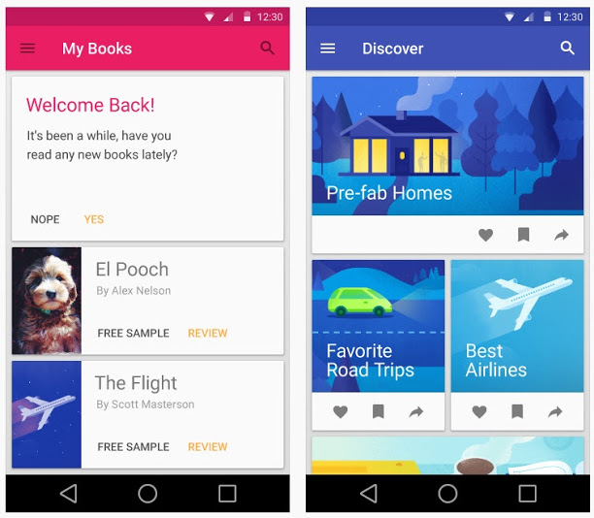

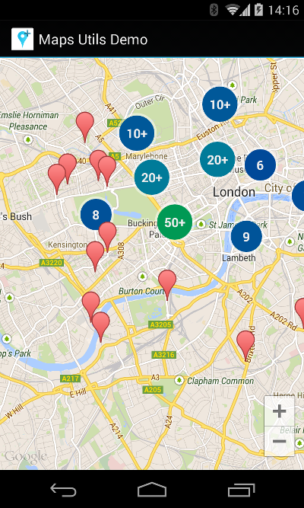

**Swipe to right:** the menu will pop on screen:

* User icon,
* settings and a number of options as well,
* profile link.

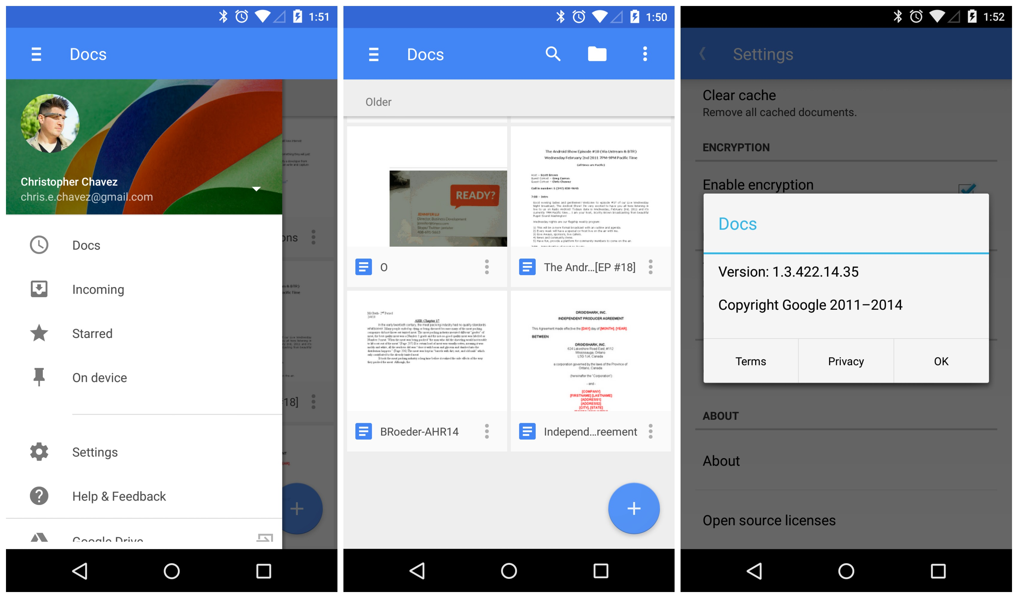  
Elements example:  
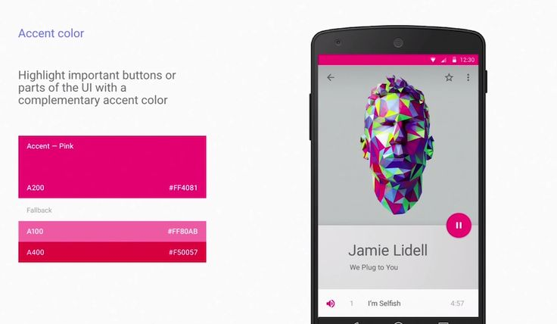

Messages between users/comments on quests:  
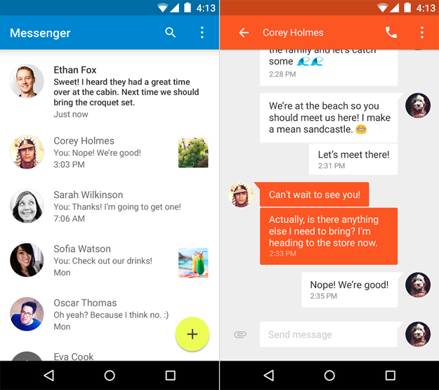

We need a page to:

* display the Quest it self,

the quest is a set of steps/tasks to complete.  
Something similar to this:  
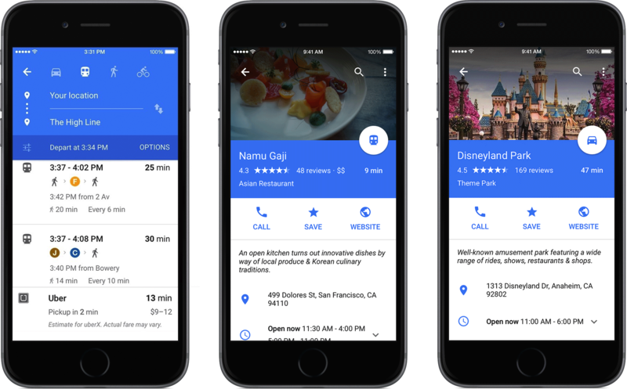

There must be:

* rating,
* section to write a review,
* and a section to comment on the event.
* Challenge friends to take quest

**Process flow:**

* **Sign in/Sign up=>Quests stream.**
* **Quests stream=> Select a quest, to view it’s details and ratings. And tasks inside it.**
* **Quest stream=>swipe right for options, profile view and so on**
* **First icon in the stream is to create a quest,**